Service Trip
Puerto Rico
4 Days, 3 Nights
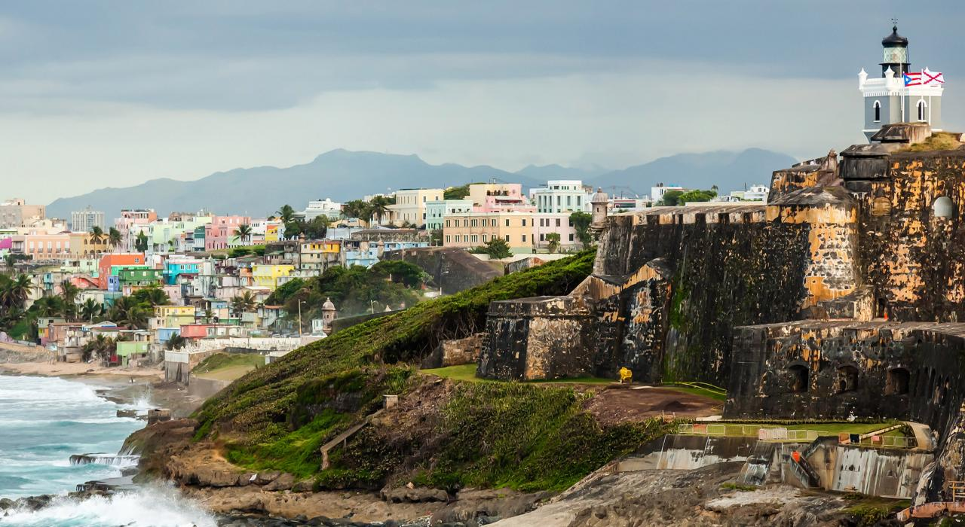
All times and activities are subject to change due to the availability at the time of booking.
Day 1:
a.m. Arrive in San Juan, Puerto Rico at Luis Munoz Marin International Airport (SJU)
A local motorcoach will be waiting for your group at passenger pick-up, outside of baggage claim.
p.m. Lunch at Miramar Food Truck Park, or similar
Located in the heart of San Juan's Miramar neighborhood, Miramar Food Truck Park offers a vibrant and diverse culinary experience. Established in 2014, the park brings together a variety of food trucks serving cuisines ranging from Puerto Rican to international flavors. With ample outdoor seating and a lively atmosphere, it's an ideal spot to enjoy a meal and soak in the local culture.
p.m. Campus Tour of University High School
Visit University High School, a highly regarded secondary school affiliated with the University of Puerto Rico. Walk through the campus, meet local students and educators, and get a firsthand look at daily academic life in Puerto Rico. This experience offers a unique perspective on the island’s educational system and opportunities for cultural exchange.
p.m. Guided Tour of Old San Juan
Explore the cobblestone streets and historic charm of Old San Juan during a guided walking tour. Learn about the city’s Spanish colonial past, visit iconic landmarks like El Morro and San Cristóbal, and take in the colorful architecture that defines this vibrant district. Along the way, you’ll hear stories that bring the city's history to life.
p.m. Arrive at the hotel
Check-in, enjoy use of amenities, and freshen up
p.m. Dinner
p.m. Arrive at the hotel
Enjoy use of amenities and rest for the night

Day 2:
a.m. Flow in for breakfast at the hotel
a.m. AmeriCorps Community Service, or similar
Support local recovery and development efforts by volunteering with a community-focused service project. Depending on the needs of the area at the time of your visit, you might help with home repairs, landscaping, painting, or organizing supplies. It’s a meaningful opportunity to contribute directly to neighborhoods that continue to rebuild and grow stronger.
p.m. Lunch
p.m. Visit La Plaza del Mercado – shopping & sightseeing [on own]
Spend some time exploring La Plaza del Mercado, a lively public market filled with local flavor and culture. Wander through shops and vendor stalls offering crafts, souvenirs, and unique finds. This self-guided visit allows for personal exploration and a closer look at everyday life in Puerto Rico.
p.m. Arrive at the hotel
Enjoy use of amenities and freshen up
p.m. Dinner & Bomba Dance Presentation, at the hotel
Experience the rhythm and energy of Puerto Rico’s Afro-Caribbean roots with a live Bomba dance presentation. This traditional style of music and dance is deeply rooted in the island’s cultural history. You’ll not only watch skilled performers but also learn about the significance of Bomba in Puerto Rican identity and storytelling.
p.m. Enjoy use of amenities and rest for the night

Day 3:
a.m. Flow in for breakfast at the hotel
a.m. Native Tree Service Project, or similar
Take part in a hands-on environmental service project aimed at restoring native tree populations and supporting local ecosystems. Activities may include planting trees, removing invasive species, or maintaining green spaces. This experience connects you to the natural landscape and highlights the importance of environmental stewardship on the island.
p.m. Lunch
p.m. Guided Tour of El Yunque
Discover the beauty of El Yunque, the only tropical rainforest in the U.S. National Forest System, during a guided tour through its lush trails. Learn about the diverse plant and animal life, the importance of rainforest conservation, and the cultural significance of this natural treasure. Along the way, enjoy scenic views, waterfalls, and the sounds of the forest.
p.m. Visit Luquillo Beach with Dinner [cash out]
Relax and unwind at Luquillo Beach, a picturesque stretch of coastline known for its calm waters and scenic backdrop. Take time to enjoy the natural beauty, walk along the sand, or simply soak in the surroundings.
p.m. Arrive at the hotel
Enjoy use of amenities and rest for the night

Day 4:
a.m. Flow in for breakfast at the hotel
Prepare for departure and check-out
a.m. Campus Tour of University of Puerto Rico
Explore the campus of the University of Puerto Rico, the island’s premier public university. Walk through its historic buildings, visit notable landmarks like the clock tower, and hear about the academic programs and student life. It’s a great way to see how higher education thrives in a rich and dynamic cultural setting.
p.m. Lunch
p.m. Transfer to the airport
p.m. Arrive at Luiz Munoz Marin International Airport (SJU)
NOTE: It is important to arrive at least two (2) hours prior to the scheduled departure time to allow for check-in, baggage check, and security screening(s).
p.m. Departure Flight
Your trip ends here – Thank you for traveling with Fourwinds!

Package Description
Tour Includes:
Four (4) Days of Motorcoach Transportation
Three (3) Nights of Hotel Accommodation
Three (3) Breakfasts, at the hotel
Four (4) Lunches, including Miramar Food Truck Park
Three (3) Dinners, including at hotel and beach cash out
Campus Tour of University High School
Guided Tour of Old San Juan
AmeriCorps Community Service, or similar
Visit La Plaza del Mercado – shopping & sightseeing [on own]
Bomba Dance Presentation, at the hotel
Native Tree Service Project, or similar
Guided Tour of El Yunque
Visit Luquillo Beach
Campus Tour of University of Puerto Rico
Gratuity for Driver(s)
Gratuity for Guide(s)
$5,000,000 Liability Coverage
Tour Does Not Include:
Roundtrip Airfare, and associated fee
Meals, unless specified in “Tour Includes”
Personal Expenses & Spending Money
Trip Cancelation Insurance
Extra Hotel Security, minimum of six (6) hours per night
Online Portal for Individual Registration & Payment

