Trailblazers India
STEM Trip to Orlando, FL
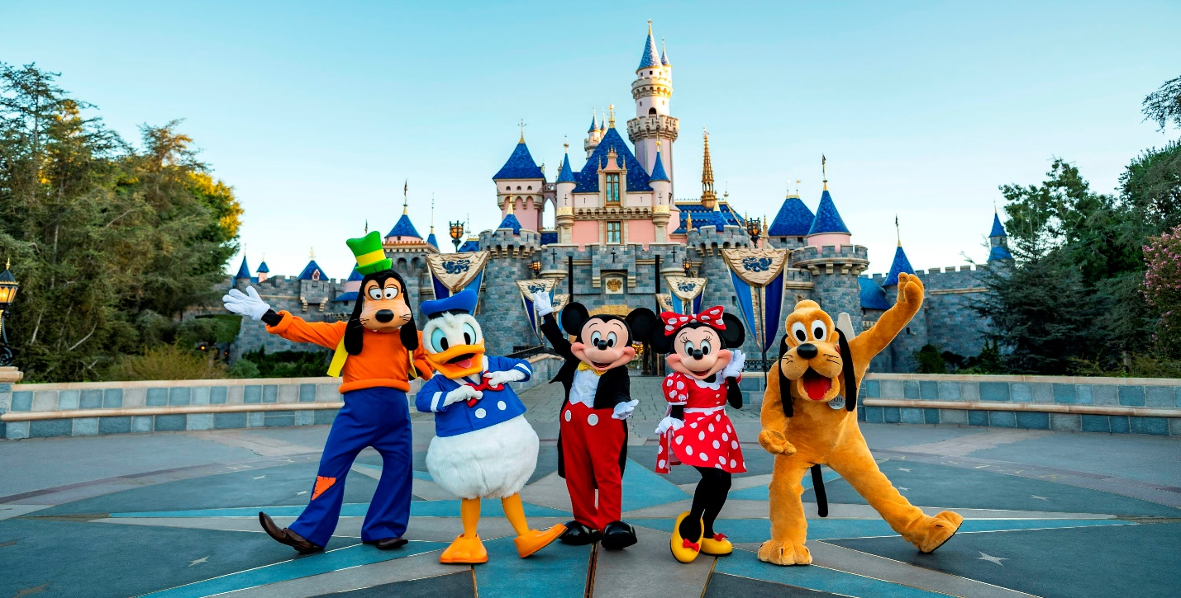

Day 01, Arrival:

Upon arrival at Orlando International Airport (MCO) this afternoon, you will be met by a private motorcoach for a comfortable transfer to your local hotel. After checking in, you’ll have a few hours to freshen up, unpack, and relax. As the sun begins to set, your private coach will transport you to Disney Springs for an evening of exploration. This vibrant pedestrian district truly comes alive at night with sparkling waterfront views and live musical performances. You’ll have the evening to browse flagship stores and high-end boutiques before heading back to your hotel via private transfer around 8:00 PM or 9:00 PM to ensure a restful end to your first day.

Meals:
Dinner will be hosted at a local restaurant in Disney Springs. A variety of Vegetarian and Non-Vegetarian dishes will be available. Please note that while dietary requests are supported, authentic Jain meals (no onion, garlic, or root vegetables) are not guaranteed at all venues and may have limited options.

Day 2, Kennedy Space Center (KSC):

Start your morning with a delicious buffet breakfast at the hotel before boarding your private motorcoach for an inspiring journey to the Kennedy Space Center. You will spend a full day exploring the epicenter of American space exploration, where you can walk among massive rockets and get an up-close view of the legendary Space Shuttle Atlantis. From the high-tech simulations at Gateway™ to the historic grounds of the Apollo/Saturn V Center, the day is packed with immersive experiences that bring the history and future of space travel to life. After a day of discovery, you will enjoy a relaxing private transfer back to your hotel, stopping for dinner at a local restaurant along the way.

Admission to Kennedy Space Center (KSC) includes:
- Gateway™: The Deep Space Launch Complex featuring Spaceport KSC
- Space Shuttle Atlantis® and the Shuttle Launch Experience®
- Kennedy Space Center Bus Tour
- Apollo/Saturn V Center
- Heroes and Legends featuring the U.S. Astronaut Hall of Fame®
- Astronaut Encounter
- Planet Play
- Rocket Garden guided tours
- Journey to Mars
- Space Films
- Other scheduled presentations and films

Meals:
- Breakfast: Buffet breakfast at the hotel.
- Lunch: Enjoy lunch at your convenience within the complex using a $20 meal voucher, valid at any of the onsite cafés.
- Dinner: Hosted at a local restaurant on the return journey to your hotel.
- Note: Vegetarian and non-vegetarian options are available; however, please note that authentic Jain meals cannot be guaranteed at all locations.

Day 3, NASA Astronaut Training Experience (ATX):

Your day begins with a hearty buffet breakfast at the hotel before you depart for a high-stakes mission at the Kennedy Space Center. You will join the next generation of space explorers in the Astronaut Training Experience® (ATX), an immersive program developed with Lockheed Martin that simulates life and work on Mars. Throughout the session, you’ll use cutting-edge NASA science and simulation technology to practice docking skills, navigate the rugged Martian terrain, and feel the unique sensation of a microgravity spacewalk. Following the program, you will have the remainder of the afternoon to explore the rest of the Space Center's world-class exhibits at your own pace. After a day of elite training, your private coach will transport you back toward your hotel, stopping for dinner along the way.

Astronaut Training Experience (ATX) Details:
- Program Focus: Immersive simulations including Mars rover navigation, docking manoeuvres, and microgravity training.
- Schedule: Starts promptly at 9:00 AM with a duration of 4–5 hours.
- Inclusions: Participants receive a commemorative T-shirt, Certificate, Lanyard, and Badge. A small snack is also included during the program.
- Group Size: Requires a minimum of 24 paying participants to run (maximum of 72).

Participant Requirements & Accessibility:
- Age: Must be at least 10 years old. Attendees under 18 must be accompanied by a participating paying adult.
- Language: Due to safety instructions, all guests must be fluent in English (reading and speaking).
- Attire: Closed-toed shoes are required. Please use caution with dresses or skirts as movement is required.
- Physicality: Guests must be able to transfer into simulators independently. This includes climbing stairs/ramps for the Rover and stepping over raised safety features for the Microgravity simulator.

Meals
- Breakfast: Buffet breakfast provided at the hotel.
- Lunch: A $20 meal voucher is provided for use at any café within the Kennedy Space Center complex.
- Dinner: Hosted at a local restaurant during the return transfer to your hotel.
- Dietary Note: Vegetarian and non-vegetarian options are readily available; however, Jain meals (no onion, garlic, or root vegetables) cannot be guaranteed at all locations.

Day 04, Disneyworld with educational workshop:

Today, you will dive into the magic of the Walt Disney World Resort, a sprawling destination where imagination meets engineering. Using your 2-Day Base Park Ticket, you have the freedom to experience a full day of wonder at the theme park of your choice: the classic Magic Kingdom Park, the globe-trotting EPCOT, the cinematic Disney’s Hollywood Studios, or the nature-inspired Disney’s Animal Kingdom Theme Park.

Your day includes a deep dive into the Physics of Disney Parks Workshop, where you will step into the shoes of a Disney Imagineer to uncover how Newton’s Laws of Motion, gravity, and kinetic energy power the world’s most famous attractions. After a full day of thrills and scientific discovery, your private coach will be waiting to transfer you back to your hotel after the park closes.

Physics of Disney Parks Workshop
- The Experience: Learn the science behind the "magic" by exploring Disney attractions as real-world physics laboratories.
- Key Principles: Study Newton’s 3 Laws of Motion, speed vs. velocity, acceleration, inertia, friction, and potential/kinetic energy.
- Learning Goals: You will participate in hands-on scientific experiments, collaborate on creative problem-solving, and even brainstorm and design your own concepts for a new guest experience.
- Requirement: A minimum of 15 students is required for this organized group workshop to take place.

Meals & Certificates
- Lunch & Dinner: Both meals are included via Disney Meal Certificates.
- How it Works: These certificates can be redeemed at a variety of Quick-Service locations across all four theme parks and Disney Springs. Typically, a certificate covers one entrée, one side, and one non-alcoholic beverage.
- Flexibility: You can choose when and where to eat, allowing you to plan your meals around your favourite rides or the workshop schedule.

Day 05, Disneyworld:

Your day is dedicated to a full immersion in the magic of Walt Disney World Resort, a world-class destination where imagination comes to life across four unique theme parks. With your Base Park Ticket, you have the opportunity to spend a full, uninterrupted day exploring the theme park of your choice.

Whether you choose to spend your entire day enjoying the classic charm of Magic Kingdom Park, the global culture of EPCOT, the cinematic thrills of Disney’s Hollywood Studios, or the natural wonders of Disney’s Animal Kingdom Theme Park, you’ll have the time to soak in every detail of your chosen destination. After a marathon day of world-class entertainment, your private motorcoach will be waiting to provide a comfortable transfer back to your hotel once the park has officially closed for the night.

Meals & Certificates
- Lunch & Dinner: Both meals are included via Disney Meal Certificates.
- How it Works: These certificates can be redeemed at a variety of Quick-Service locations across all four theme parks and Disney Springs. Typically, a certificate covers one entrée, one side, and one non-alcoholic beverage.
- Flexibility: You can choose when and where to eat, allowing you to plan your meals around your favourite rides or the workshop schedule.

Day 06, Beach Day:

Begin your day with a hearty buffet breakfast at the hotel before boarding your private motorcoach for a transfer to Cocoa Beach, Orlando's iconic coastal getaway. Known as the surfing capital of the East Coast, this destination offers a full day of sun-soaked fun, where you can stroll along the historic Westgate Cocoa Beach Pier, explore the world-famous Ron Jon Surf Shop, or simply relax on the Atlantic sands. Following a local lunch by the shore, you will transfer back to Orlando in the late afternoon. The excitement continues in the evening with a visit to Universal CityWalk, the "Epicenter of Awesome," for a night of vibrant sightseeing, flagship shopping, and high-energy entertainment before a private transfer back to your hotel for a restful night.

Daily Highlights
- Cocoa Beach Adventure: Enjoy a day of coastal discovery, featuring the 800-foot pier and the massive Ron Jon flagship store.
- Universal CityWalk: Experience Orlando’s premier entertainment district, home to themed boutiques, street performers, and the famous Universal globe.

Meals & Dietary Notes
- Breakfast: Full buffet breakfast served at the hotel.
- Lunch: Hosted at a local restaurant near Cocoa Beach, offering a relaxing break during your seaside excursion.
- Dinner: Hosted at a local restaurant at Universal CityWalk, perfectly positioned amidst the evening's shopping and sights.
- Dietary Note: Vegetarian and non-vegetarian options are readily available; however, Jain meals (no onion, garlic, or root vegetables) cannot be guaranteed at all locations.

Day 07, Departure:

On your final day in Orlando, enjoy a final buffet breakfast at the hotel before completing the check-out process. Once your luggage is packed and loaded onto the private motorcoach, you will say farewell to the "Theme Park Capital of the World" and transfer to Orlando International Airport (MCO). From there, you will begin your return journey back to India, carrying with you incredible memories of space training, Disney magic, and the sun-soaked shores of Florida.

Meals & Dietary Notes
- Breakfast: Full buffet breakfast served at the hotel.
- Note: Vegetarian and non-vegetarian options are available for breakfast; however, authentic Jain meals (no onion, garlic, or root vegetables) may have limited availability at the hotel buffet.

The Trip ends here! Thank You for travelling with Four Winds!!

PRICING:

Paying Students | Complimentary Chaperones in DOUBLE OCCUPANCY | Price Per Person
 |  | QUAD | TRIPLE | DOUBLE | SINGLE
50 | 5 | $1899 | $2139 | $2319 | $3159
40 | 4 | $1995 | $2235 | $2415 | $3255
30 | 3 | $2119 | $2359 | $2539 | $3379
20 | 2 | $2375 | $2615 | $2795 | $3635

If you have less than 20 paying travelers per coach, the per person price will go up.

Price may go up slightly due to the possible increase of busing/fuel costs.
Prices for Holiday weeks may vary slightly. If you add any activities that require further driving, the price will go up.

Extra hotel security is an additional $50 – 60 per hour per guard / 6-hour minimum per night.

TOUR INCLUDES:
7 Days Motor Coach Transportation.
6 Nights Hotel Accommodation.
Meals:
6 x Buffet Breakfast at the hotel.
Lunch at a local restaurant.
2 x Lunch using meal voucher at KSC - $20.
2 x Lunch using Disney Meal Certificates.
2 x Dinner using Disney Meal Certificates.
4 x Dinner at a local restaurant.
Attractions:
Admission to Disney Parks using 2-Day Base Park Ticket. (1 Day – 1 Park only)
Physics of Disney Parks Workshop
2 Day Ticket to Kennedy Space Center.
Astronaut Training Experience (ATX)
Visit Disney Springs.
Visit Cocoa Beach.
Visit Universal CityWalk.
Tip for Bus Driver.

TOUR DOES NOT INCLUDE:
Round-trip Airfare from India.
Cancellation Insurance.
Meals, unless specified.
Personal Expenses.
Tip for Guide. [If any]

