This sample itinerary is a flexible guide that can be customized to better align with your specific educational goals and students’ needs. Whether you need to lengthen or shorten the trip, adjust the activities, or account for the distance from your school, we are here to accommodate your group.

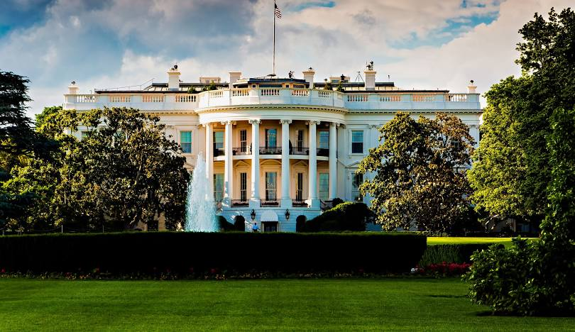
Honoring Excellence: An HBCU Exploration
Washington, D.C.
4 Days, 3 Nights

Discover the rich legacy of Historically Black Colleges and Universities (HBCUs) on this four-day journey through Washington, D.C. and beyond. This tour provides a firsthand look at the pillars of academic achievement and the cultural pride that have empowered generations of Black leaders. From the vibrant campuses of Morgan State and Howard University to the profound history chronicled at the National Museum of African American History and Culture, each stop connects past, present, and future.

Day 1:
- Arrive in Washington, D.C.
- Dinner at local restaurant
Day 2:
- Continental breakfast at the hotel
- Morgan State University Campus Tour, subject to availability
- Coppin State University Campus Tour, subject to availability
- Bowie State University Campus Tour, subject to availability
- Admission to Dave & Buster’s – Dinner and Gaming, subject to availability
Day 3:
- Continental breakfast at the hotel
- Visit the White House for a Photo Op
- Admission to the National Museum of African American History & Culture, subject to availability
- Admission to choice of Smithsonian Museum, subject to availability
- Explore the National Mall Memorials and Monuments
- Guided Illumination Monument and Memorial Tour, subject to availability
Day 4:
- Continental breakfast at the hotel
- Howard University Campus Tour, subject to availability
- Transfer to your school

