Trip to Gatlinburg, TN
Fantasy Lights Christmas Parade &
Dollywood Theme Park Performances
4 Days, 3 Nights
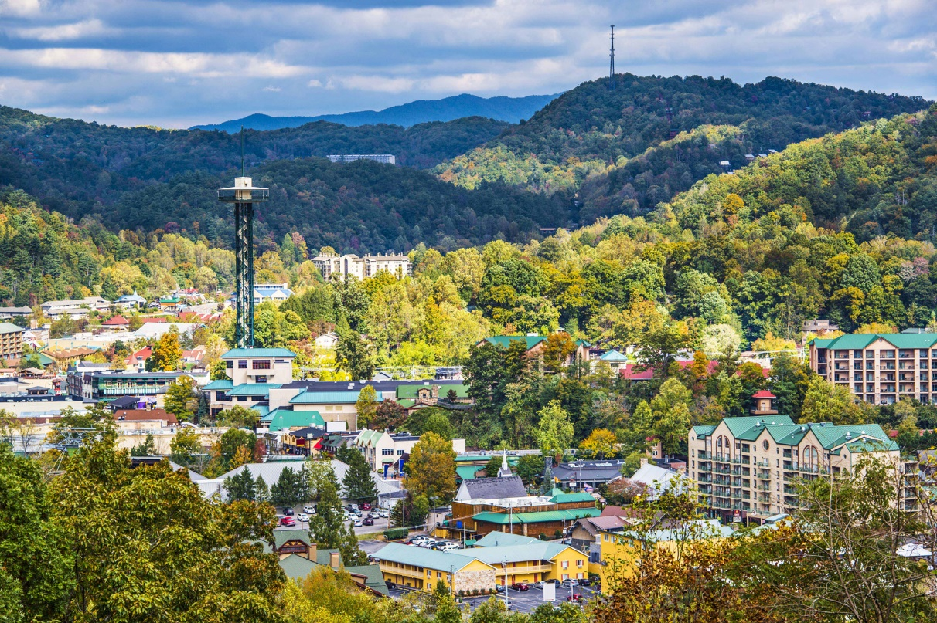
All times and activities are subject to change

Day 1: Arrival
a.m. Buses arrive at your school
p.m. Transfer to Gatlinburg, TN
p.m. Lunch [on own]
p.m. Dinner [on own]
p.m. Arrive at the hotel
Check-in, enjoy use of amenities, and rest for the night

Day 2: Cades Cove, Ripley’s, & Fantasy of Lights Parade
7:30 a.m. Flow in for continental breakfast at the hotel
8:00 a.m. Boxed lunch delivery to hotel
NOTE: Please pack accordingly to keep your lunch with you during your tour.
8:15 a.m. Meet your tour guides - Transfer to Great Smoky Mountains National Park
Approximately a 30-minute drive, subject to traffic and hotel location
9:00 a.m. Guided tour of Cades Cove, subject to availability
Nestled in the heart of the Great Smoky Mountains; you’ll find Cades Cove. It’s an area lush with history, wildlife, and some of the most beautiful views you’ll find in the park. An expert guide will take you on a memorable and educational experience. Whether you’re a regular visitor to Cades Cove or this is your first time, there’s always something new to learn or see. Discover the history of the Cove and share in the personal stories of its people.
Duration: 4-hours
1:00 p.m. Transfer to Ripley’s Aquarium of the Smokies – Time for lunch [boxed] on the bus
Approximately a 1.5-hour drive, subject to traffic
2:30 p.m. Admission to Ripley’s Aquarium of the Smokies, subject to availability
Exotic sea creatures, stingrays, and horseshoe crabs. See the longest underwater tunnel and shark exhibit. With thousands of incredible creatures in exhibits like Shark Lagoon, Ray Bay, Penguin Playhouse, and more. Ripley's aquariums are known for their shark exhibits that feature 10-foot sharks and two of the longest underwater tunnels in the world.
4:00 p.m. Transfer to dinner
4:15 p.m. Dinner
5:30 p.m. Dinner ends – Change into uniforms on the buses
6:00 p.m. Transfer to First Baptist Gatlinburg
Approximately a 15-minute drive, subject to traffic
6:35 p.m. Line-up to march in the parade
7:30 p.m. Fantasy of Lights Parade begins
More than 60,000 people have lined the streets to watch the nationally televised award-winning parade featuring lighted floats, high school marching bands, giant balloons, and of course Santa Claus! The approximately 1-hour parade route runs through the middle of downtown Gatlinburg. You will march non-stop for the duration of the parade.
9:00 p.m. Transfer to the hotel
Approximately a 45-minute drive, subject to traffic
9:45 p.m. Arrive at the hotel
Enjoy use of amenities and rest for the night
Day 3: Dollywood with Performance
8:00 a.m. Flow in for continental breakfast at the hotel
10:00 a.m. Meet your tour guides at the hotel – Transfer to Dollywood
Approximately a 30-minute drive, subject to traffic
11:00 a.m. Admission to Dollywood: Dollywood’s Smoky Mountain Christmas
Explore a Christmas of many colors and rides at Dollywood this holiday season! Slow down for a scenic stroll through the park and notice how each land tells a seasonal story through its unique and vibrant hues. Discover Santa's Village with its classic red and green, the crisp blues and whites of winter in Glacier Ridge, a soft candlelight glow throughout Craftsman's Valley, and more. Towering up to 12 feet tall, dozens of spectacular Christmas trees inspire a sense of childlike wonder, reminding us of what this special season is all about. The spirit of the season shines brightest during Smoky Mountain Christmas, voted America's Best Christmas Event for more than a decade.
11:45 a.m. Marching Band Stationary Performance with Dollywood Performing Stars
NOTES:
- Groups must arrive 15 – 30 minutes prior to performance time.
- All performances must be ‘stand still’ [No movement at all]. Auxiliaries can perform in place. No flags/batons/pom poms can leave the performers hands.
- Dollywood provides electricity [2 Outlets], chairs, music stands, and 2 – 3 mics.
- No instruments are provided. Groups can bring their own amps.
- Uniforms are not required. Matching T-shirts will suffice.
p.m. Lunch [on own]
p.m. Dinner [cash out or meal voucher]
9:00 p.m. Transfer to the hotel
Approximately a 30-minute drive, subject to traffic
9:30 p.m. Arrive at the hotel
Enjoy use of amenities and rest for the night
Day 4: Departure
a.m. Flow in for continental breakfast at the hotel
Check-out and load buses
a.m. Depart for your school
p.m. Lunch – on own
p.m. Dinner – on own
p.m. Arrive at your school

Your trip ends here - Thank you for traveling with Fourwinds!

Package Description
Tour includes:
Tour guides - days 2 & 3
Four (4) days of motorcoach transportation
Three (3) nights of hotel accommodation
Three (3) continental breakfasts at the hotel
Lunch [boxed] – day 2
Dinner – day 2
Dinner [meal voucher or cash out] – day 3
Guided tour of Cades Cove, subject to availability
Admission to Ripley’s Aquarium of the Smokies, subject to availability
March in the Fantasy of Lights Parade, subject to availability and application approval
Admission to Dollywood: Dollywood’s Smoky Mountain Christmas
Stationary Performance at Dollywood, subject to availability
Gratuity for driver(s)
Gratuity for tour guides – day 2 & 3
Tour does not include:
Meals unless specified
Personal expenses
Trip cancellation insurance
Online portal for individual registration/payment
Additional hotel security – minimum of 6 hours per night

