This sample itinerary is a flexible guide that can be customized to better align with your specific educational goals and students’ needs. Whether you need to lengthen or shorten the trip, adjust the activities, or account for the distance from your school, we are here to accommodate your group.

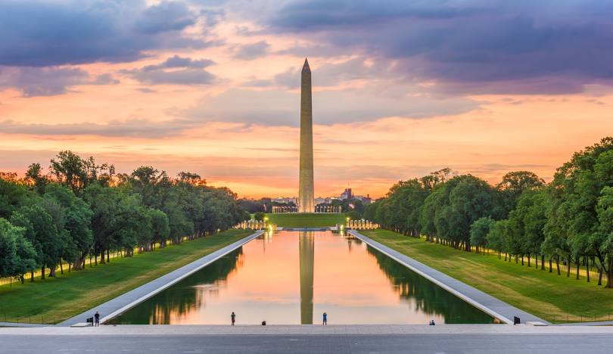
Journey Through U.S. Liberty and Civil Rights
Washington, D.C. & Jamestown, VA
6 Days, 5 Nights

This seven-day itinerary traces the evolution of freedom and civil rights in America, offering a reflective journey through the nation’s history. Beginning in Washington, D.C., explore pivotal sites that highlight the struggle for equality and the pursuit of justice. Experience the powerful narratives of civil rights leaders and foundational moments of American democracy, and visit key landmarks that symbolize the nation’s commitment to liberty. Continue to Jamestown to discover the roots of American society and the early foundations of freedom. Explore the sites of revolutionary significance and become immersed in the story of the nation’s quest for independence.

Day 1:
- Arrive in Washington, D.C.
- Admission to the National Museum of African American History & Culture, subject to availability
- Visit the Frederick Douglass National Historic Site, subject to availability
- Dinner at local restaurant
Day 2:
- Continental breakfast at the hotel
- Visit the Supreme Court Building, subject to availability
- Walking Tour of the National Mall Monuments & Memorials, subject to availability
- Dinner at local restaurant
Day 3:
- Continental breakfast at the hotel
- Admission to the Library of Congress, subject to availability
- Admission to the African American Civil War Museum, subject to availability
- Visit the Arlington National Cemetery, subject to availability
- Dinner at local restaurant
Day 4:
- Continental breakfast at the hotel
- Admission to the National Museum of American History, subject to availability
- Transfer to Jamestown
- Tour of Historic Jamestown, subject to availability
- Dinner at local restaurant
Day 5:
- Continental breakfast at the hotel
- Admission to the American Revolution Museum at Yorktown, subject to availability
- Visit the Yorktown Battlefield, subject to availability
- Dinner at local restaurant
Day 6:
- Continental breakfast at the hotel
- Admission to Colonial Williamsburg, subject to availability
- Dinner at local restaurant
Day 7:
- Continental breakfast at the hotel
- Admission to the Jamestown Settlement, subject to availability
- Transfer to your school

