Service Trip
Quebec & Montreal, Canada
6 Days, 5 Nights
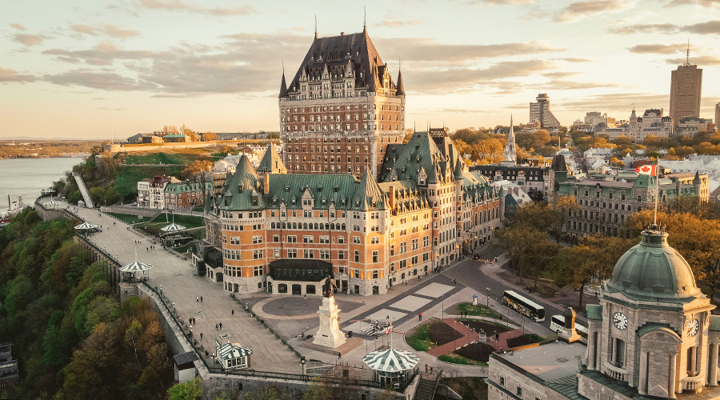
All times and activities are subject to change due to the availability at the time of booking.
Day 1:
a.m. Arrive in Quebec, Canada
a.m. La Citadelle de Quebec Visit with Workshop
Discover one of North America’s most important historic military sites with a guided tour of La Citadelle de Québec, an active military installation and home to the Royal 22e Régiment. Perched atop Cap Diamant, the Citadel offers stunning views of the St. Lawrence River and Québec City.
The visit includes a hands-on workshop (topics may include: military life, symbols and traditions, Canadian peacekeeping, or leadership and teamwork), connecting to different themes based on students level.

p.m. Lunch
2:00 p.m. Admission to the Observatoire de la Capital with Workshop
Enjoy breathtaking 360-degree views of Québec City from the highest point in town at the Observatoire de la Capitale. Students will gain a unique perspective on the city’s geography, architecture, and history.
Following the visit, take part in a hands-on educational workshop designed to deepen understanding of Québec's cultural, linguistic, and historical significance. Workshops are tailored for student engagement and aligned with educational goals such as language immersion, Canadian history, or civic awareness.
p.m. Admission to The Plains of Abraham Museum
Step into Canada’s rich military past at the Plains of Abraham Museum, located in the heart of the historic Battlefields Park. Students will explore interactive exhibits that bring to life the pivotal Battle of Québec (1759) and its lasting impact on Canadian history.
p.m. Dinner
p.m. Arrive at the Hotel
Check-in, enjoy use of amenities, and rest for the night
Day 2:
a.m. Flow in for breakfast at the hotel
a.m. Ice Skating at Centre de Glaces de Quebec
A world-class ice sports facility located in Québec City. This state-of-the-art complex is dedicated to speed skating, figure skating, hockey, and other ice-related disciplines, and is one of the top venues of its kind in North America.
p.m. Lunch
p.m. Guided Tour of Old Québec and Lévis Ferry Experience
Explore the heart of Old Québec, a UNESCO World Heritage Site, on foot with an expert local guide. This immersive tour brings centuries of history to life as students walk through charming cobblestone streets, admire the city’s unique architecture, and learn about the French and British influences that have shaped Québec's identity.
To finish the tour, students will board the Lévis Ferry for a short scenic ride across the St. Lawrence River to Lévis and back, offering stunning panoramic views of Québec City’s skyline—perfect for reflection, photos, and discussion.
p.m. Explore Quartier du Petit Champlain – shopping & sightseeing [on own]
Nestled at the foot of Cap Diamant in Old Québec, this picturesque neighborhood feels like a step back in time, with its narrow cobblestone streets, colorful historic buildings, and artisanal boutiques. Enjoy exploring local shops and Québec-made crafts, Discovering the story of Samuel de Champlain and early French settlement, and viewing murals and public art that illustrate Québec’s heritage This visit is ideal for fostering appreciation of Francophone culture, urban history, and Québecois identity in a fun, interactive setting.
p.m. Dinner
p.m. Arrive at the hotel
Enjoy use of amenities and rest for the night

Day 3:
a.m. Flow in for breakfast at the hotel
Prepare for departure and check-out
a.m. Community Service Project, subject to program
p.m. Visit Montmorency Falls with Lunch, Re-Enactment Tour, and Cable Car Ride
Workshop: Montmorency Attack Ahoy Ahou! - Amerindians, French and English are cordially invited to participate in a re-enactment of the Battle of Montmorency! Immerse yourself in the universe of the summer of 1759 and play as your favorite character on this educational tour. Muster enough courage and rise to the challenge of collecting Louis gold pieces and taking part in the final great battle.

Cable Car Ride: Hop aboard and open your eyes wide! The cable car is the perfect vantage point from which to watch the 83-metre-high waterfall flow into the St. Lawrence River. It takes only a few minutes to reach Manoir Montmorency from the Lower terminal at the level of the St. Lawrence. Enjoy the ride and an exceptional view! It can accommodate 40 people per gondola.

p.m. Dinner

p.m. Arrive at the hotel
Check-in, enjoy use of amenities, and rest for the night

Day 4:
a.m. Flow in for breakfast at the hotel
a.m. Visit Mont Royal
The lookout on top of Mount Royal is an excellent goal for an urban walk. It's in Mount Royal Park, laid out long ago by Frederick Law Olmsted, best known for landscaping New York's Central Park. The top of Mount Royal is divided between the park and two large cemeteries, the Catholic Notre-Dame-des-Neiges cemetery and the non-denominational Mount Royal cemetery.
p.m. Lunch
p.m. Arrive at the hotel
Enjoy use of amenities and freshen up
p.m. Guided Tour of Downtown Montreal
Explore the vibrant heart of Montreal on a guided tour through its bustling downtown district. Discover a mix of historic architecture, modern skyscrapers, and lively cultural spots as your guide shares insights into the city’s rich heritage and contemporary life. This tour offers a great way to experience Montreal’s unique blend of French and English influences.
p.m. Dinner
p.m. Visit Eaton Center Montreal – shopping [on own]
Visit the Eaton Centre, one of Montreal’s premier shopping destinations located in the city’s downtown core. Featuring a wide range of shops, eateries, and entertainment options, the mall offers something for every taste and style. It’s an ideal stop for a bit of retail therapy or to experience the lively urban atmosphere.
p.m. Arrive at the hotel
Enjoy use of amenities and rest for the night

Day 5:
a.m. Flow in for breakfast at the hotel
a.m. Community Service Project, subject to program
p.m. Lunch
p.m. Café Graffiti Workshop
Café Graffiti is a social hub for youth to express themselves through art, and dance. This organization provides a living environment for young people, to promote their professional recognition, fight exclusion and raise self-esteem
An animator will start with an explanation to how to do graffiti writing. Then the students will practice on papers. Then they do their tag on a hat to bring home.
p.m. Dinner at Sugar Shack, or similar
p.m. Arrive at the hotel
Enjoy use of amenities and rest for the night

Day 6:
a.m. Flow in for breakfast at the hotel
Prepare for departure and check-out
a.m. Departure
Your trip ends here – Thank you for traveling with Fourwinds!

Package Description
Tour Includes:
Six (6) Days of Motorcoach Transportation
Five (5) Nights of Hotel Accommodation
Five (5) Breakfasts, at the hotel
Five (5) Lunches
Five (5) Dinners
La Citadelle de Quebec Visit with Workshop
Admission to the Observatoire de la Capital with Workshop
Admission to The Plains of Abraham Museum
Ice Skating at Centre de Glaces de Quebec
Guided Tour of Old Québec and Lévis Ferry Experience
Explore Quartier du Petit Champlain – shopping & sightseeing [on own]
Community Service Project, subject to program
Visit Montmorency Falls with Lunch, Re-Enactment Tour, and Cable Car Ride
Visit Mont Royal
Guided Tour of Downtown Montreal
Visit Eaton Center Montreal – shopping [on own]
Community Service Project, subject to program
Café Graffiti Workshop
Gratuity for Driver(s)
Gratuity for Guide(s)
$5,000,000 Liability Coverage
Tour Does Not Include:
Roundtrip Airfare, and associated fee
Meals, unless specified in “Tour Includes”
Personal Expenses & Spending Money
Trip Cancelation Insurance
Extra Hotel Security, minimum of six (6) hours per night
Online Portal for Individual Registration & Payment

