This sample itinerary is a flexible guide that can be customized to better align with your specific educational goals and students’ needs. Whether you need to lengthen or shorten the trip, adjust the activities, or account for the distance from your school, we are here to accommodate your group.

West Coast & National Parks
Camp / Teen Tour
20 Days, 19 Nights
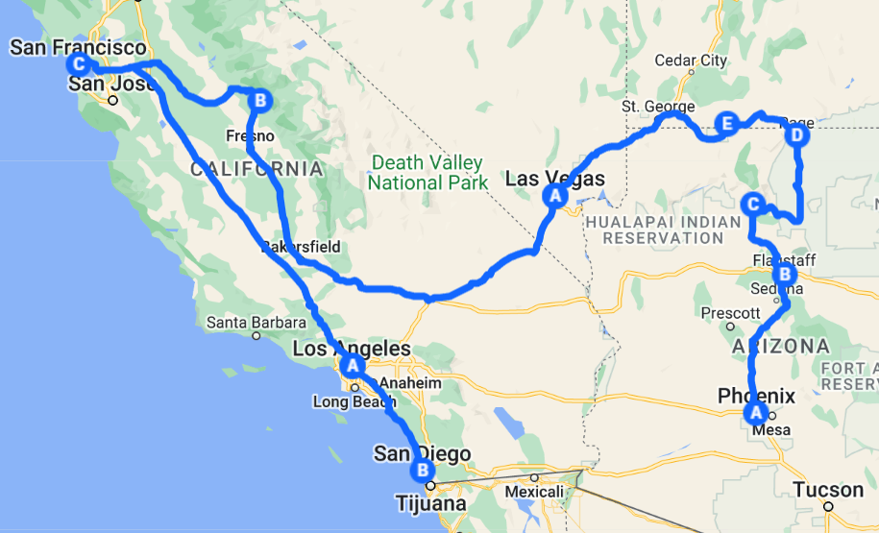

Get ready for an unforgettable adventure across the stunning landscapes and vibrant cities of the Southwest and California! This three-week teen tour is designed to inspire exploration and creativity for your campers. From the breathtaking beauty of the Grand Canyon to the iconic attractions of Los Angeles and the natural wonders of San Diego, each day is packed with exciting activities and opportunities to create lasting memories. With a mix of outdoor adventures, interactive entertainment, and cultural experiences, this journey promises to ignite a sense of wonder and connection to the incredible sights and sounds of the region.
Week 1: Discovering the Southwest
Kick off your adventure in the heart of the Southwest, where exploration and excitement await! This week is all about embracing new experiences, from the vibrant atmosphere of Phoenix to the breathtaking beauty of the Grand Canyon. Engage with the stunning natural landscapes and enjoy a variety of thrilling activities that foster teamwork and friendship. As you embark on this journey of discovery, prepare to create memories that will last a lifetime!
Week 2: Connecting to Nature
As you transition into California, this week emphasizes the theme of connection—both to the natural world and to the rich cultural experiences of the region. From the historic significance of the Hoover Dam to the natural wonders of Yosemite National Park, each day encourages appreciation for the beauty and diversity of the landscapes. Enjoy engaging activities that promote personal growth and deeper friendships, all while exploring iconic attractions that highlight the essence of California.
Week 3: The Spirit of Southern California
The final week of your journey celebrates the joy of learning and adventure in the vibrant cities of Los Angeles and San Diego. This week is all about immersion in new experiences, from the educational insights gained at museums to the fun-filled adventures at Disneyland and local beaches. Embrace the spirit of camaraderie as you explore diverse attractions and engage in meaningful activities, culminating in an unforgettable finale that captures the essence of your incredible journey together.
This three-week adventure is not just a trip; it's an incredible experience that encourages adventure, curiosity, and personal growth. Join us for a journey filled with fun, learning, and camaraderie, and get ready to create unforgettable memories and friendships that will last a lifetime!

Week 1: Discovering the Southwest
Day 1:
- Flight to Phoenix, AZ
- Lunch [cash out]
- Explore Westgate Entertainment District
- Dinner [local restaurant]
Day 2:
- Breakfast at the hotel
- Games & Lunch at Dave & Buster’s, subject to availability
- Transfer to Flagstaff, AZ
- Explore Downtown Flagstaff
- Dinner [cash out]
- Admission to Lowell Observatory
Day 3:
- Breakfast at the hotel
- Visit the Grand Canyon
- Lunch [cash out]
- Laser Tag & Pizza at FlagTag AZ, subject to availability
Day 4:
- Breakfast at the hotel
- Antelope Canyon Boat Tour, subject to availability
- Lunch [cash out]
- Explore Page
- Red Heritage Dinner Show, subject to availability
- Transfer to Kanab, UT

Day 5:
- Breakfast at the hotel
- Visit Zion National Park
- Lunch [cash out]
- Enjoy use of amenities
- Dinner [local restaurant]
Day 6:
- Breakfast at the hotel
- Transfer to Las Vegas, NV
- Paintball at Las Vegas Premier Paintball, subject to availability
- Lunch [cash out]
- Explore the LINQ Promenade
- Admission to Meow Wolf – Omega Mart, subject to availability
- Dinner [local restaurant]
Day 7:
- Breakfast at the hotel
- Guided Tour of Las Vegas
- Lunch [cash out]
- Explore Las Vegas – Visit the Bellagio Fountains
- Dinner [local restaurant]
- Admission to the Neon Museum, subject to availability
--- --- --- --- --- --- --- --- --- --- --- --- --- --- --- --- ---
Week 2: Connecting to Nature
Day 8:
- Breakfast at the hotel
- Guided Hoover Dam Power Plant Tour, subject to availability
- Visit Hoover Dam Visitor Center
Day 8 (cont.):
- Lunch [cash out]
- Admission to Cowabunga Bay, subject to availability
- Dinner [hotel]
- Tickets to the Sphere, subject to availability
Day 9:
- Breakfast at the hotel
- Campus Tour of UNLV, subject to availability
- Lunch [cash out]
- Explore Shoppes at Mandalay Place
- Admission to the Shark Reef Aquarium, subject to availability
- Dinner [cash out]
- Tickets to the Blue Man Group, subject to availability
Day 10:
- Breakfast at the hotel
- Transfer to Oakhurst, CA
- Lunch [cash out]
- Dinner [hotel]
- Yoga at Local Park, subject to availability
Day 11:
- Breakfast at the hotel
- Visit Yosemite National Park – Mariposa Grove, subject to availability
- Lunch [cash out]
- Dinner [hotel]

Day 12:
- Breakfast at the hotel
- Transfer to San Mateo, CA
- Explore San Mateo
- Lunch [cash out]
- Admission to Muir Woods, subject to availability
- Visit Golden Gate Bridge Welcome Center/Vista Point
- Explore PIER 39
- Dinner [cash out]
Day 13:
- Breakfast at the hotel
- Ferry to / Explore Alcatraz Island, subject to availability
- Lunch [cash out]
- Dinner [local restaurant
Day 14:
- Breakfast at the hotel
- Transfer to Los Angeles, CA
- Lunch [cash out]
- Visit Venice Beach
- Visit Santa Monica Pier
- Dinner [cash out]
--- --- --- --- --- --- --- --- --- --- --- --- --- --- --- --- ---
Week 3: The Spirit of Southern California
Day 15:
- Breakfast at the hotel
- Admission to the LA Holocaust Museum, subject to availability
- Explore the Grove
Day 15 (cont.):
- Lunch [cash out]
- Explore Old Town Monrovia
- Cooking Class, subject to availability
Day 16:
- Breakfast at the hotel
- Admission to Disneyland, subject to availability
- Lunch [cash out]
- Dinner [cash out]
Day 17:
- Breakfast at the hotel
- Beach Day with Kayaking, SUP, & Games, subject to availability
- Lunch [cash out]
- Dinner [local restaurant]
- Visit Griffith Observatory
Day 18:
- Breakfast at the hotel
- Transfer to San Diego, CA
- Admission to San Diego Zoo, subject to availability
- Lunch [cash out]
- Tickets to San Diego Padres Baseball Game, subject to availability
- Dinner [cash out]

Day 19:
- Breakfast at the hotel
- Sea Cave Kayaking, subject to availability
- Explore La Jolla
- Lunch [cash out]
- Sunset Dinner & S’mores on the Beach, subject to availability
Day 20:
- Transfer to the airport
- Breakfast [cash out]
- Flight home
- Transfer back to camp

