This sample itinerary is a flexible guide that can be customized to better align with your specific educational goals and students’ needs. Whether you need to lengthen or shorten the trip, adjust the activities, or account for the distance from your school, we are here to accommodate your group.

US South
Camp / Teen Tour
23 Days, 22 Nights
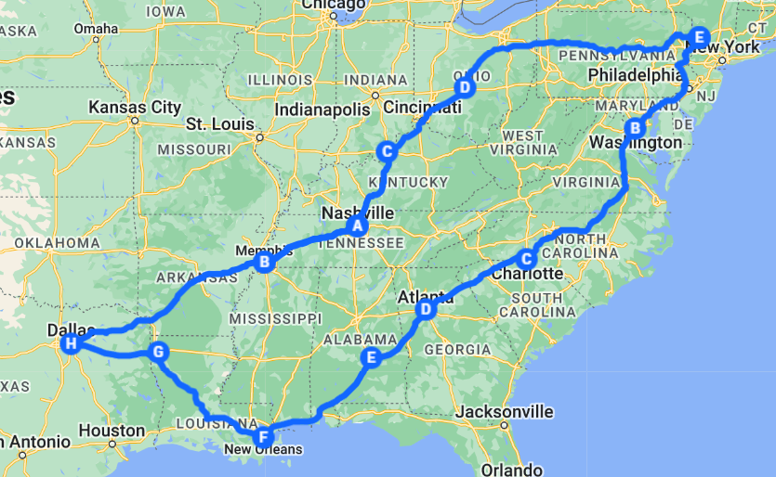

Get ready for an unforgettable three-week adventure that will take you on a journey through the heart and soul of America! This teen tour is designed to inspire curiosity and foster connections as we explore vibrant cities filled with rich history, diverse cultures, and exciting experiences. From engaging museums to thrilling activities, each week is designed to foster exploration and connection among fellow campers. Let the adventure begin!

Week 1: East Coast Exploration
We kick off our adventure with an exploration of the East Coast, journeying to the vibrant cities of Washington, DC, Charlotte, and Atlanta. Participants will delve into fascinating histories and cultures, visiting significant landmarks and engaging museums that spark curiosity and conversation. This week promises a blend of guided experiences and free exploration, ensuring that every moment is filled with fun, learning, and the chance to forge lifelong friendships.
Week 2: Southern Adventure
Our journey continues southward as we immerse ourselves in the rich cultural tapestry of Atlanta, New Orleans, and Dallas. Each day is packed with exhilarating adventures, from the lush landscapes of the Atlanta Botanical Garden to the historical depths of the National WWII Museum in New Orleans. Participants will engage with the unique traditions of each city while enjoying lively tours and delicious meals, creating lasting memories and camaraderie along the way.
Week 3/4: Heart and Soul of America: Music & Heritage
We conclude our adventure by diving into the heart of America, where history, culture, and music intertwine in vibrant cities like Memphis and Nashville, along with a stop in Columbus, Ohio. Participants will experience the soulful rhythms of Memphis, exploring the legacy of the Civil Rights Movement and music legends, before soaking in the dynamic atmosphere of Nashville, known as Music City. With a perfect mix of educational activities and thrilling outings, this final week is set to create unforgettable memories filled with laughter, exploration, and discovery.
This three-week adventure is not just a trip; it's an incredible experience that encourages adventure, curiosity, and personal growth. Join us for a journey filled with fun, learning, and camaraderie, and get ready to create unforgettable memories and friendships that will last a lifetime!

Week 1: East Coast Exploration
Day 1:
- Transfer Washington, D.C.
- Lunch [cash out]
- Admission to the Capital Jewish Museum, subject to availability
- Dinner [local restaurant]
Day 2:
- Breakfast at the hotel
- Visit the White House, subject to availability
- Lunch [cash out]
- Entrance to Smithsonian Museum(s)
- Dinner [local restaurant]
- Illumintation Monument & Memorial Tour, subject to availability
Day 3:
- Breakfast at the hotel
- Admission to Udvar-Hazy National Ari & Space Museum, subject to availability
- Lunch [cash out]
- Campus Tour of University of Maryland, subject to availability
- Explore Baltimore Inner Harbor
- Dinner [local restaurant]
Day 4:
- Breakfast at the hotel
- Transfer to Charlotte, NC
- Lunch [cash out]
- Uptown Interactive Art Walk
- Dinner [local restaurant]

Day 5:
- Breakfast at the hotel
- Mine Tour & Gold Panning at Reed Gold Mine, subject to availability
- Lunch [cash out]
- Admission to Carowinds, subject to availability
- Dinner [cash out]
Day 6:
- Breakfast at the hotel
- Admission to the NASCAR Hall of Fame, subject to availability
- Lunch [cash out]
- Go-Karting at Victory Lane, subject to availability
- Transfer to Atlanta, GA
- Dinner [cash out]
Day 7:
- Breakfast at the hotel
- Atlanta Black History & Civil Rights Tour, subject to availability
- Lunch [cash out]
- Visit Centennial Olympic Park
- Dinner [local restaurant]
- Bowling & Games at Main Event, subject to availability
--- --- --- --- --- --- --- --- --- --- --- --- --- --- --- --- ---
Week 2: Southern Adventure
Day 8:
- Breakfast at the hotel
- Admission to Atlanat Botanical Gardens, subject to availability
Day 8 (cont.):
- Campus Tour of Emory University, subject to availability
- Lunch [cash out]
- Admission to World of Coca-Cola Atlanta, subject to availability
- Hip-Hop Bus Tour, subject to availability
- Dinner [local restaurant]
Day 9:
- Breakfast at the hotel
- Transfer to Montgomery, AL
- Explore Montgomery
- Lunch [cash out]
- Transfer to New Orleans, LA
- Dinner [hotel]
Day 10:
- Breakfast at the hotel
- Cajun Encounters Swamp Tour, subject to availability
- Lunch [cash out]
- Admission to the Museum of Southern Jewish Experience, subject to availability
- Jazz Dinner Cruise aboard Steamboat Natchez, subject to availability
Day 11:
- Breakfast at the hotel
- Admission to the National WWII Museum, subject to availability
- Lunch [cash out]
- Admission to Mardi Gras World, subject to availability
- Campus Tour of Tulane University, subject to availability
Day 11 (cont.):
- Explore the French Quarter
- Dinner [local restaurant]
- Stop at Café Du Monde, subject to availability
Day 12:
- Breakfast at the hotel
- Transfer to Shreveport, LA
- Explore Shreveport
- Lunch [cash out]
- Transfer to Dallas, TX
- Dinner [hotel]
- Line Dancing Lesson [hotel], subject to availability
Day 13:
- Breakfast at the hotel
- Southfork Ranch Tour, subject to availability
- Tickets to Texas Rangers Baseball Game, subject to availability
- Lunch [cash out]
- Dinner [local restaurant]
Day 14:
- Breakfast at the hotel
- Admission to the Sixth Floor Museum, subject to availability
- Admission to Six Flags Over Texas, subject to availability
- Lunch [cash out]
- Dinner [cash out]
--- --- --- --- --- --- --- --- --- --- --- --- --- --- --- --- ---
Week 3/4: Heart and Soul of America: Music & Heritage
Day 15:
- Breakfast at the hotel
- Transfer to Memphis, TN
- Lunch [cash out]
- Admission to the National Civil Rights Museum, subject to availability
- Dinner [local restaurant]
- Game Night [hotel], subject to availability
Day 16:
- Breakfast at the hotel
- Tour of Sun Studio, subject to availability
- Lunch [cash out]
- Guided Memphis Walking Tour, subject to availability
- Dinner [local restaurant]
- Explore Beale Street
Day 17:
- Breakfast at the hotel
- Admission to Graceland, subject to availability
- Lunch [cash out]
- Dinner [local restaurant]
- Admission to Nights at Heights at Go Ape!, subject to availability
Day 18:
- Breakfast at the hotel
- Transfer to Nashville, TN
- Lunch [cash out]
- Music City Walk of Fame
- Explore Nashville
- Dinner [local restaurant]
- Tickets to the Grand Ole Opry, subject to availability
Day 19:
- Breakfast at the hotel
- Visit Centennial Park
- Admission to the Parthenon, subject to availability
- Lunch [cash out]
- Admission to the Country Music Hall of Fame, subject to availability
- Stop at Savannah’s Candy Kitchen
- Explore Nashville
- Dinner [local restaurant]
Day 20:
- Breakfast at the hotel
- Campus Tour of Vanderbilt University, subject to availability
- Spend Time at Old Hickory Beach, subject to availability
- Lunch [boxed meal]
- Dinner [local restaurant]
- 2-Hours of Laser Tag at Phazer Kraze, subject to availability
Day 21:
- Breakfast at the hotel
- Transfer to Louisville, KY
- Explore Louisville
- Lunch [cash out]
- Transfer to Columbus, OH
- Dinner [local restaurant]

Day 22:
- Breakfast at the hotel
- Campus Tour of Ohio State University, subject to availability
- Lunch [cash out]
- Admission to the Columbus Zoo, subject to availability
- Dinner [local restaurant]
- Paintball at LVL Up Sports, subject to availability
Day 23:
- Breakfast at the hotel
- Transfer back to camp
- Lunch [cash out]

