This sample itinerary is a flexible guide that can be customized to better align with your specific educational goals and students’ needs. Whether you need to lengthen or shorten the trip, adjust the activities, or account for the distance from your school, we are here to accommodate your group.

US North + Niagara Falls + Toronto
Camp / Teen Tour
23 Days, 22 Nights

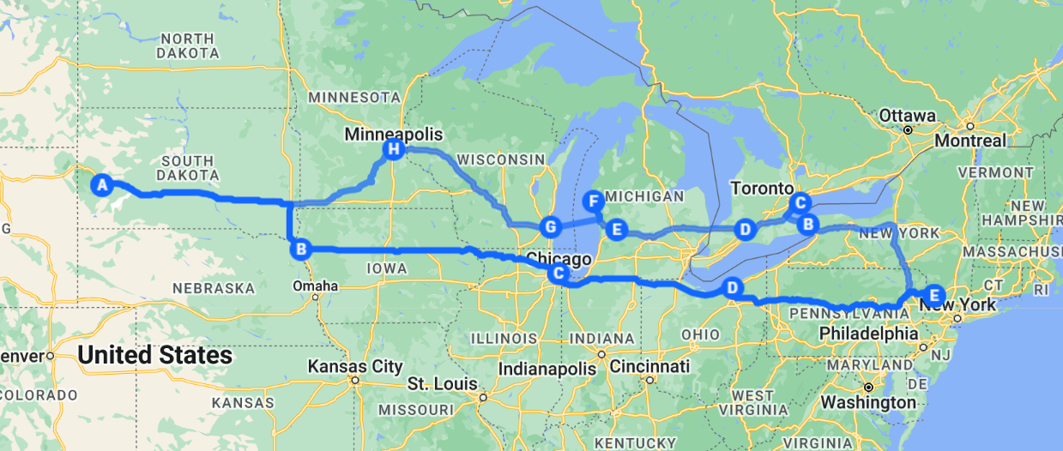

Welcome to an exhilarating three-week adventure designed specifically for teens! This unforgettable tour will take you through breathtaking landscapes, vibrant cities, and iconic landmarks as you explore the natural beauty of Niagara Falls, the charm of the Midwest, and the thrilling attractions of America’s most famous sites.
Week 1: Niagara Falls and Toronto
Your journey kicks off with an incredible week in Niagara Falls and the vibrant city of Toronto. Experience the awe-inspiring beauty of the Falls, delve into the rich history of hockey, and immerse yourself in the lively culture of Canada’s largest city. From thrilling boat rides and guided tours to interactive museum visits and outdoor activities, each day is filled with engaging experiences that foster camaraderie and lasting memories. Get ready for a week packed with excitement, laughter, and new friendships as we explore the beauty and spirit of these remarkable destinations!
Week 2: The Midwest Adventure
In the second week, the adventure continues as we journey across the Midwest, exploring the beauty and charm of Michigan, Wisconsin, Minnesota, and South Dakota. From art and culture at the Frederik Meijer Gardens & Sculpture Park to the thrills of ziplining at John Ball Zoo, every day brings a mix of adventure, learning, and fun. Dance the night away in Milwaukee, explore the iconic Mall of America, and enjoy dynamic city experiences that encourage teens to bond, challenge themselves, and create lasting memories.
Week 3/4: Iconic Landmarks and Natural Wonders
The final week takes us through some of America’s most iconic landmarks and breathtaking natural wonders. Explore the majestic Mount Rushmore, engage in interactive activities at the Dorothy Pecaut Nature Center, and immerse yourself in the rich history at the Illinois Holocaust Museum. With thrilling rides at Cedar Point Amusement Park and the stunning beauty of the Badlands, each day promises opportunities for exploration, education, and connection.
This three-week adventure is not just a trip; it's an incredible experience that encourages adventure, curiosity, and personal growth. Join us for a journey filled with fun, learning, and camaraderie, and get ready to create unforgettable memories and friendships that will last a lifetime!

Week 1: Niagara Falls and Toronto
Day 1:
- Transfer to Niagara Falls, ON
- Lunch [cash out]
- Voyage of the Falls, subject to availability
- Dinner [local restaurant]
- Admission to Clifton Hill: Fun by the Falls, subject to availability
Day 2:
- Breakfast at the hotel
- Admission to Journey Behind the Falls, subject to availability
- Whirlpool Jet Boat Tour, subject to availability
- Lunch [cash out]
- Admission to White Water Walk, subject to availability
- Dinner [local restaurant]
- Admission to Skylon Towers, subject to availability
Day 3:
- Breakfast at the hotel
- Transfer to Toronto, ON
- Guided Tour of Toronto, subject to availability
- Lunch [cash out]
- Admission to the Hockey Hall of Fame, subject to availability
- Dinner [local restaurant]
- Spirits of the Distillery District Ghost Tour, subject to availability

Day 4:
- Breakfast at the hotel
- Explore Nathan Phillips Square
- Group Photo in front of the Toronto Sign
- Admission to the Royal Ontario Museum, subject to availability
- Lunch [cash out]
- Admission to CN Towers, subject to availability
- Dinner [local restaurant]
Day 5:
- Breakfast at the hotel
- Ferry to & Explore Center Island/Toronto Islands, subject to availability
- Lunch [boxed meal]
- 2-hours of Bowling & Pizza Dinner at Playtime Bowl, subject to availability
Day 6:
- Breakfast at the hotel
- Transfer to London, ON
- Visit Ska-Nah-Doht Village and Museum with guided tours/activities, subject to availability
- Lunch [cash out]
- Transfer to Grand Rapids, MI
- Dinner & Movie [hotel], subject to availability
Day 7:
- Breakfast at the hotel
- Hike the Aman Park Loop, subject to availability
- Lunch [cash out]

Day 7 (cont.):
- Grand Rapids Guided Bus Tour, subject to availability
- Dinner [local restaurant]
- 3-Hour Unlimited Wristband at Craig’s Cruisers, subject to availability
--- --- --- --- --- --- --- --- --- --- --- --- --- --- --- --- ---
Week 2: The Midwest Adventure
Day 8:
- Breakfast at the hotel
- Admission to Frederik Meijer Gardens & Sculpture Park, subject to availability
- Lunch [cash out]
- Admission to Sky Trail Ropes Course + Zipline & the John Ball Zoo, subject to availability
- Dinner [local restaurant]
- Swing & Line Dancing Class, subject to availability
Day 9:
- Breakfast at the hotel
- Transfer to Mears, MI
- Sand Dune Buggy Ride, subject to availability
- Transfer to Milwaukee, WI
- Lunch [cash out]
- DJ Dinner Dance [hotel], subject to availability
Day 10:
- Breakfast at the hotel
- Admission to the Jewish Museum Milwaukee, subject to availability
Day 10 (cont.):
- Lunch [cash out]
- Admission to Mithcell Park Domes, subject to availability
- Dinner [local restaurant]
- Unlimited Gameplay at Garcade, subject to availability
Day 11:
- Breakfast at the hotel
- Milwaukee Scavenger Hunt, subject to availability
- Lunch [cash out]
- Transfer to Minneapolis, MN
- Dinner [local restaurant]
Day 12:
- Breakfast at the hotel
- Explore Mall of America
- Tickets to FlyOver America, subject to availability
- Lunch [cash out]
- Visit Lake Nokomis with Use of Rentals, subject to availability
- Dinner [local restaurant]
- Visit Minneapolis Sculpture Garden, subject to availability
Day 13:
- Breakfast at the hotel
- Transfer to Rapid City, SD
- Lunch [cash out]
- Dinner & Game Night [hotel], subject to availability

Day 14:
- Breakfast at the hotel
- Admission to (drive-thru) Bear Country USA, subject to availability
- Lunch [cash out]
- Admission to Reptile Gardens, subject to availability
- Dinner [local restaurant]
--- --- --- --- --- --- --- --- --- --- --- --- --- --- --- --- ---
Week 3/4: Iconic Landmarks and Natural Wonders
Day 15:
- Breakfast at the hotel
- Transfer to Keystone, SD
- Visit Mount Rushmore National Memorial, subject to availability
- Lunch [cash out]
- Tube Hill & Alpine Slide Riding at Rushmore Tramway Adventures, subject to availability
- Dinner [local restaurant]
Day 16:
- Breakfast at the hotel
- Transfer to Badlands National Park
- Visit Badlands National Park, subject to availability
- Lunch [cash out]
- Transfer to Sioux City, IA
- Dinner [cash out]

Day 17:
- Breakfast at the hotel
- Visit Dorothy Pecaut Nature Center, subject to availability
- Lunch [cash out]
- Visit Palmer Candy Shoppe
- Explore Sioux Falls
- Dinner [local restaurant]
- Mini-Golf at North Forty, subject to availability
Day 18:
- Breakfast at the hotel
- Transfer to Chicago, IL
- Lunch [cash out]
- Dinner & Game Night [hotel], subject to availability
Day 19:
- Breakfast at the hotel
- Admission to Illinois Holocaust Museum & Education Center, subject to availability
- Lunch [cash out]
- Explore Navy Pier
- Ride on the Centennial Wheel, subject to availability
- Dinner [local restaurant]
- Admission to Whirlyball, subject to availability
Day 20:
- Breakfast at the hotel
- Admission to the Lincoln Park Zoo, subject to availability
- Tickets to Chicago Cubs Baseball Game, subject to availability
Day 20 (cont.):
- Lunch [cash out]
- Dinner [local restaurant]
- Admission to Skydeck, subject to availability
Day 21:
- Breakfast at the hotel
- Visit Cloud Gate – Group Photo
- Transfer to Sandusky, OH
- Admission to the Rock & Roll Hall of Fame, subject to availability
- Dinner [local restaurant]
- Night Sky Viewing at Observatory Park, subject to availability
Day 22:
- Breakfast at the hotel
- Admission to Cedar Point Amusement Park, subject to availability
- Lunch [cash out]
- Dinner [cash out]
Day 23:
- Breakfast at the hotel
- Transfer back to camp
- Lunch [cash out]

