Service Trip
Costa Rica
5 Days, 4 Nights
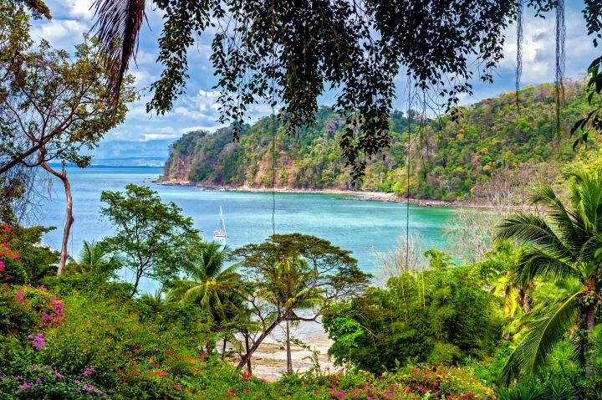
All times and activities are subject to change due to the availability at the time of booking.
Day 1:
a.m. Arrive in San Jose, Costa Rica at Juan Santamaria International Airport (SJO)
A local motorcoach will be waiting for your group at passenger pick-up, outside of baggage claim.
a.m. Campus Tour of Costa Rica
Explore the main campus of the University of Costa Rica, one of the most prestigious public universities in Central America. Walk through its spacious grounds, modern research facilities, and historic academic buildings while learning about the university’s role in shaping Costa Rican society. The visit offers a unique window into the country’s higher education system and its commitment to innovation, sustainability, and public service.
p.m. Arrive at Accommodations
p.m. Lunch & Orientation
Upon arrival, settle into your volunteer accommodations and get to know the local community. A welcome briefing will introduce you to the area’s conservation efforts and the important role volunteers play in protecting native wildlife. Orientation includes a safety overview, cultural insights, and a training session that prepares you for the work ahead—including your role in helping to safeguard sea turtle populations.
p.m. Dinner
p.m. Nighttime Turtle Patrol
Once trained, take part in an unforgettable nighttime turtle patrol along the remote beaches of Costa Rica’s Caribbean coast. Join local conservationists to monitor nesting sea turtles, protect their eggs from predators and poachers, and gather data that supports marine conservation efforts. Walking the beach under the stars offers a powerful opportunity to witness nature in action and contribute directly to the survival of these incredible creatures.
p.m. Rest for the night

Day 2-Day 4:
a.m. Flow in for breakfast
a.m.  - p.m. | Daily Volunteer Services, subject to program  Daily volunteer activities will be determined by the local organization based on current needs. These may include monitoring and protecting nesting sea turtles, relocating eggs to hatcheries, supervising hatchling releases, conducting beach clean-ups, and collecting environmental data. Occasionally, volunteers also assist with property upkeep such as painting, light cleaning, garbage removal, and gardening to help maintain the community-run conservation site.
p.m. Lunch
p.m. Return to Accommodations
p.m. Cultural/Local Activity, subject to program
Outside of volunteer service, you’ll have opportunities to immerse yourself in the local culture and environment. This may include traditional dance lessons like merengue and cumbia, cooking classes featuring fresh Costa Rican cuisine, visits to artisan markets, and tours of the local turtle hatchery. Relax with a swim at the secluded Barrita Lagoon, take boat tours along the biodiverse Parismina River, trek through the nearby jungle to spot wildlife, or simply unwind on the beautiful beaches just steps from your accommodation.
p.m. Dinner
p.m. Rest for the night

Day 5:
a.m. Flow in for breakfast
Prepare for departure
a.m. Campus Tour of EARTH University
Tour EARTH University, an internationally recognized institution known for its focus on sustainable agriculture and community development. Located in a lush tropical setting, the campus serves as a living laboratory where education and environmental responsibility go hand in hand. During the visit, gain insight into how EARTH prepares future leaders to drive positive change through hands-on learning and ecological stewardship.
p.m. Lunch
p.m. Transfer to the airport
p.m. Arrive at Juan Santamaria International Airport (SJO)
NOTE: It is important to arrive at least two (2) hours prior to the scheduled departure time to allow for check-in, baggage check, and security screening(s).
p.m. Departure Flight
Your trip ends here – Thank you for traveling with Fourwinds!

Package Description
Tour Includes:
Transportation in CR, as needed
Four (4) Nights of Accommodation
Four (4) Breakfasts, at the hotel
Five (5) Lunches
Four (4) Dinners
Campus Tour of University of Costa Rica
Nighttime Turtle Patrol
Daily Volunteer Service, subject to program
Activity, subject to program
Gratuity for Driver(s)
$5,000,000 Liability Coverage
Tour Does Not Include:
Roundtrip Airfare, and associated fee
Meals, unless specified in “Tour Includes”
Personal Expenses & Spending Money
Trip Cancelation Insurance
Extra Hotel Security, minimum of six (6) hours per night
Online Portal for Individual Registration & Payment

