Trailblazers India
STEM Trip to Boston & NYC

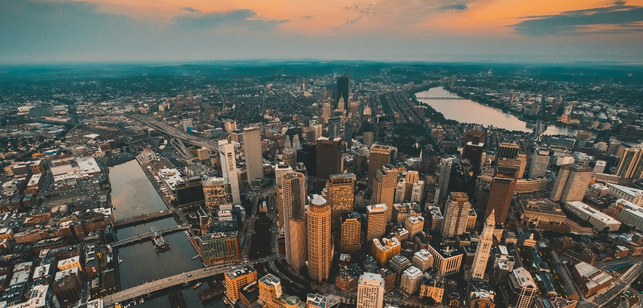

Day 01, Arrival:

Upon your afternoon arrival at Logan International Airport (BOS), you will be met by a private motorcoach for a seamless transfer directly to your local hotel. After checking in, take some time to settle in, freshen up, and relax from your travels. In the evening, the group will head to the historic Quincy Market in downtown Boston. You’ll have the opportunity to explore the various shops and soak in the vibrant atmosphere of Faneuil Hall Marketplace. For dinner, you will receive a Jassby card pre-loaded with a $20 allotment, which functions just like a debit card and is accepted by the diverse array of food vendors throughout the market. After satisfying your appetite and finishing your shopping, the motorcoach will provide a scheduled transfer back to the hotel for the night.

Daily Meal Summary:
- Lunch: On own / In-transit
- Dinner: Quincy Market ($20 Jassby Card provided)

Day 02, Robotics Workshop and Science Museum:

Start your day with a buffet breakfast at the hotel before heading out via private motorcoach for an engaging morning. Your first stop is a two-hour Robotics Workshop at the MassRobotics STEM Lab, where you will dive into hands-on technical activities.

Following the workshop, the group will enjoy lunch at a local restaurant before continuing to the world-renowned Museum of Science, Boston, to explore its many interactive exhibits. To wrap up the afternoon, the motorcoach will transfer the group to Dave & Buster’s for two hours of gaming and a group dinner. At the end of the evening, you will be transferred back to the hotel.

Daily Meal Summary
- Breakfast: Full Buffet at the Hotel
- Lunch: Local Boston Restaurant
- Dinner: Group Dinner at Dave & Buster’s
- Note: Vegetarian and non-vegetarian options are available; however, please note that authentic Jain meals cannot be guaranteed at all locations.

Day 03, Harvard and MIT:

Begin your day with a buffet breakfast at the hotel before departing via private motorcoach for an intellectually stimulating morning in Cambridge. Your first stop is an educational workshop at the MIT Museum, where you will engage in hands-on learning within their state-of-the-art labs. Following the session, you will have time for a visit to the MIT Museum galleries to explore the institute's latest breakthroughs in technology and art.

In the afternoon, the group will head to historic Harvard Square. You will have time for exploration and lunch using a Jassby card, with a $15 allotment provided for use at various local vendors. This is followed by a campus tour of both Harvard University and MIT, offering an insider’s look at the prestige and student life of these world-class institutions. The day concludes with a dinner at a local restaurant before your motorcoach transfers you back to the hotel.

Daily Meal Summary
- Breakfast: Full Buffet at the Hotel
- Lunch: Harvard Square ($15 Jassby Card provided)
- Dinner: Local Restaurant in Cambridge or Boston
- Note: Vegetarian and non-vegetarian options are available; however, please note that authentic Jain meals cannot be guaranteed at all locations.

Day 04, Boston Local:

After enjoying a buffet breakfast at the hotel, you will depart via private motorcoach for a guided walking tour of the historic Freedom Trail, walking in the footsteps of America’s founding fathers. The tour concludes at Quincy Market, where you will have time for lunch using a Jassby card with a $15 allotment to spend at any of the market's many local vendors.

In the afternoon, you’ll experience the city from two perspectives on a Boston Duck Tour, traveling in a renovated World War II amphibious vehicle that splashes right into the Charles River. Following the tour, the group will visit the New England Aquarium to see the famous giant ocean tank and penguin colonies. After dinner at a local restaurant, the evening takes a spooky turn with a 90-minute Ghosts & Gravestones Tour. You will walk amongst the dead in burying grounds nearly four hundred years old, hear stories of those whose mortal remains lie beneath your feet, and listen to tales of the sordid practices of Boston’s past. At the end of the night, your motorcoach will provide the transfer back to the hotel.

Daily Meal Summary:
- Breakfast: Full Buffet at the Hotel
- Lunch: Quincy Market ($15 Jassby Card provided)
- Dinner: Local Boston Restaurant
- Note: Vegetarian and non-vegetarian options are available; however, please note that authentic Jain meals cannot be guaranteed at all locations.

Day 05, Transfer to NYC and NYC local:

Following an early breakfast at the hotel, you will board a private motorcoach for a scenic drive from Boston to New York City. Upon your arrival in the city, you will head straight to the world-famous Times Square. You will have time to explore the bright lights and energy of the "Crossroads of the World" before enjoying lunch at a local restaurant in the heart of the district.

The afternoon continues with a visit to the iconic Empire State Building, where you can take in breathtaking panoramic views of the city skyline. After your visit, you will enjoy dinner at a local restaurant followed by the highlight of the evening: a Broadway show of your choice. Once the curtain falls, your motorcoach will transport you to your local hotel in the New Jersey area, conveniently located close to the city, for check-in and overnight stay.

Daily Meal Summary
- Breakfast: Early Buffet at the Boston Hotel
- Lunch: Local Restaurant in Times Square
- Dinner: Local New York City Restaurant
- Note: Vegetarian and non-vegetarian options are available; however, please note that authentic Jain meals cannot be guaranteed at all locations.

Day 06, Statue of Liberty and Liberty Science Center:

After enjoying a buffet breakfast at the hotel, you will depart via private motorcoach for an iconic morning visiting the Statue of Liberty and the Ellis Island Museum. You’ll explore these historic landmarks and take in the sights of the New York Harbor. For lunch, the group will use Jassby cards with a $15 allotment, which can be used at the various food service locations on the islands.

In the afternoon, the motorcoach will take you to the Liberty Science Center, where you can engage with interactive exhibits and live science demonstrations. Following your visit, you will enjoy dinner at a local restaurant before heading to the world-famous Rockefeller Center. You’ll have time for shopping and exploring the plaza's famous sights before being transferred back to your hotel for the evening.

Daily Meal Summary
- Breakfast: Full Buffet at the Hotel
- Lunch: Statue of Liberty / Ellis Island ($15 Jassby Card provided)
- Dinner: Local Restaurant
- Note: Vegetarian and non-vegetarian options are available; however, please note that authentic Jain meals cannot be guaranteed at all locations.

Day 07, Back to India:

The day has finally come to bid farewell after an unforgettable journey. Following a final breakfast at the hotel, you will check out and board your private motorcoach for a comfortable transfer to John F. Kennedy International Airport (JFK). As you prepare for your flight back to India, you'll have time to reflect on the incredible experiences you’ve shared—from the historic streets and cutting-edge labs of Boston to the iconic landmarks and bright lights of New York City. Safe travels on your journey home!

Daily Meal Summary
- Breakfast: Full Buffet at the Hotel

The Trip ends here! Thank You for travelling with Four Winds!!

PRICING:

Paying Students | Complimentary Chaperones in DOUBLE OCCUPANCY | Price Per Person
 |  | QUAD | TRIPLE | DOUBLE | SINGLE
50 | 5 | $1825 | $2035 | $2245 | $3085
40 | 4 | $1959 | $2169 | $2379 | $3219
30 | 3 | $2189 | $2399 | $2609 | $3449
20 | 2 | $2485 | $2695 | $2905 | $3745
If you have less than 20 paying travelers per coach, the per person price will go up.

Price may go up slightly due to the possible increase of busing/fuel costs.
Prices for Holiday weeks may vary slightly. If you add any activities that require further driving, the price will go up.

Extra hotel security is an additional $50 – 60 per hour per guard / 6-hour minimum per night.

TOUR INCLUDES:
7 Days Motor Coach Transportation in as per the itinerary.
6 Nights Hotel Accommodation. [3-or-4-star properties]
Meals:
6 x Buffet Breakfast at the hotel.
2 x Lunch at a local restaurant.
Lunch at Harvard Square using Jassby Cards - $15 pp.
Lunch at Quincy Market using Jassby Cards - $15 pp.
Lunch at Statue of Liberty using Jassby Cards - $15 pp.
4 x Dinner at a local restaurant.
2 Hours of gaming and dinner at Dave and Busters.
Dinner at Quincy Market using Jassby Cards - $20 pp.
Attractions:
Admission to Museum of Science.
Admission to New England Aquarium.
Admission to Empire State Building Observatory.
Admission to Liberty Science Center.
Admission to MIT Museum.
Workshop at MIT Museum.
2 Hours Robotics Workshop at MassRobotics.
Campus Tour of Harvard University.
Campus Tour off MIT.
Guided Walking Tour of Freedom Trail.
Boston Duck Tour.
Ghosts & Gravestones Haunted Tour.
Tickets to Broadway Show - $75 allowance per person.
Ferry to and from Statue of Liberty & Ellis Island.
Visit Rockefeller Center.
Visit Quincy Market.
Visit Harvard Square.
Visit Times Square.
Tip for Guide.
Tip for Bus Driver.

TOUR DOES NOT INCLUDE:
Round-trip Airfare from India.
Cancellation Insurance.
Meals, unless specified.
Personal Expenses.

